Update BIOS guide

1. Format the U disk to FAT32 format

2. copy file “startup_nsh” to U disk

3. start up the device, press F7, then choose shell

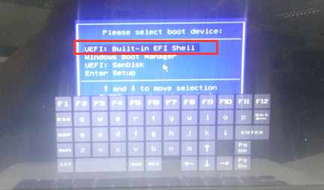

Note: after finish update BIOS, take out U disk, press ctrl+alt+del to restart.